

**AUC Catelog**

Andrew Nady

900184042

**1) Entity-Relationship Diagram of the AUC Catalog Database**

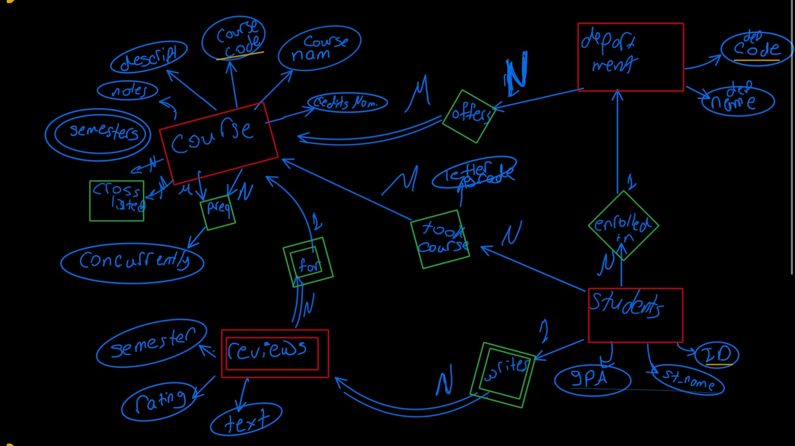

NOTES:

* I made the relation between Department and Course M to N, as there are some courses offered by many departments as Calc 3 offered in all Engineering departments.
* I made reviews as a week entity as it can not defined by itself, it have to be defined by the course and the student ( that is why I thought of making it as a relation between the student and the course entity, but I did not as I feel it should be a separate entity which has its own attributes)
* I made the Cross listed and the preq courses as relations between courses and itself, so when we want to know the preq courses for a specific course we can search by the course code (EX: CSCE 2022)
* Students can exist without department (undeclared students)
* Courses cannot exist without a department
* Reviews cannot exist without a course and a student
* Students can exist without courses (EX:gap year)

**2) Relational Model for your system**

* Department (dep_name, dep_code)
* Course (course_name, course_code, credits_nom, description, notes)
* CourseDepartment (course_code ,dep_code)

FK: course_code, dep_code

* courseSemester (course_code, semester)

FK: course_code

* CoursePreq (course_code, Preq_course_code, concurrently)

FK: course_code, Preq_course_code

* Students (st_name, ID, dep_code, GPA)

FK: dep_code

* Took_course (ID, course_code, letter_grade)

FK: ID, course_code

* Review (course_code, ID, semester, rating, Text)

FK: course_code, ID

* Crosslisted(course_code, cross_ course_code)

FK: course_code, cross_ course_code